Lecture 122 - Elastic Load Balancer - Introduction

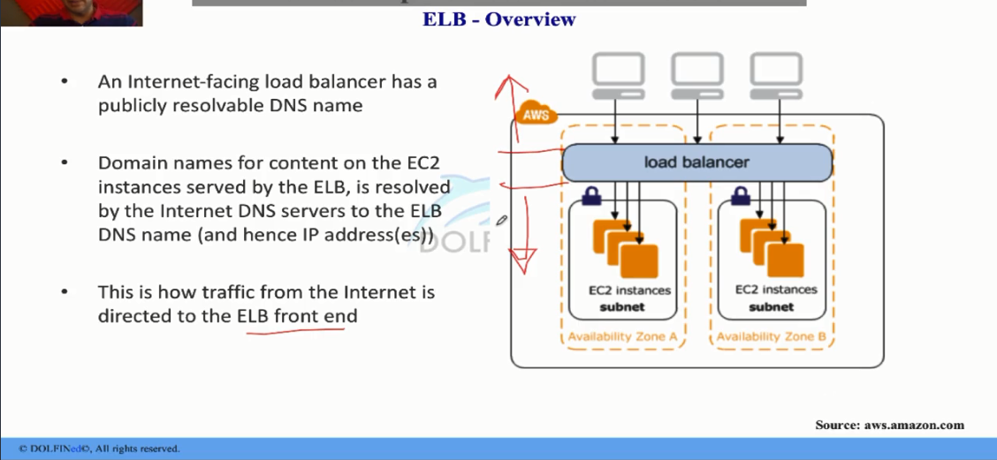

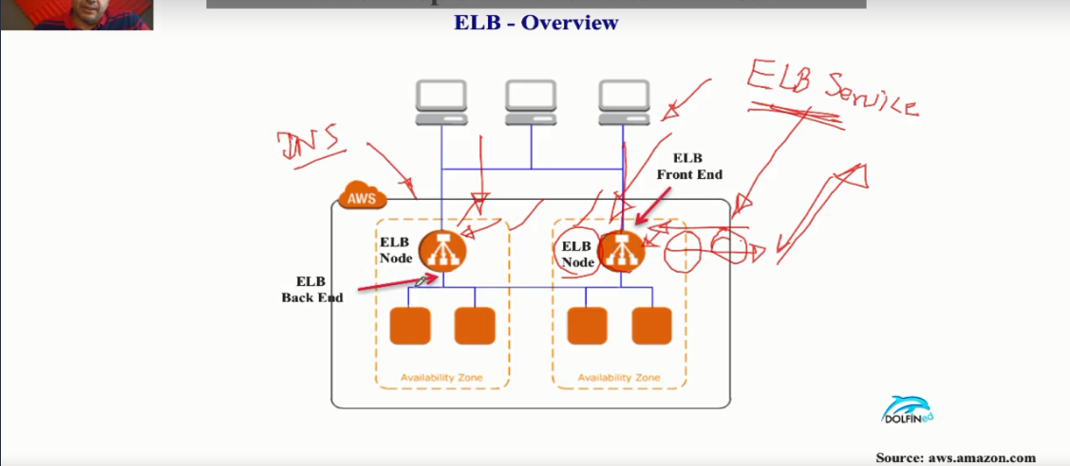

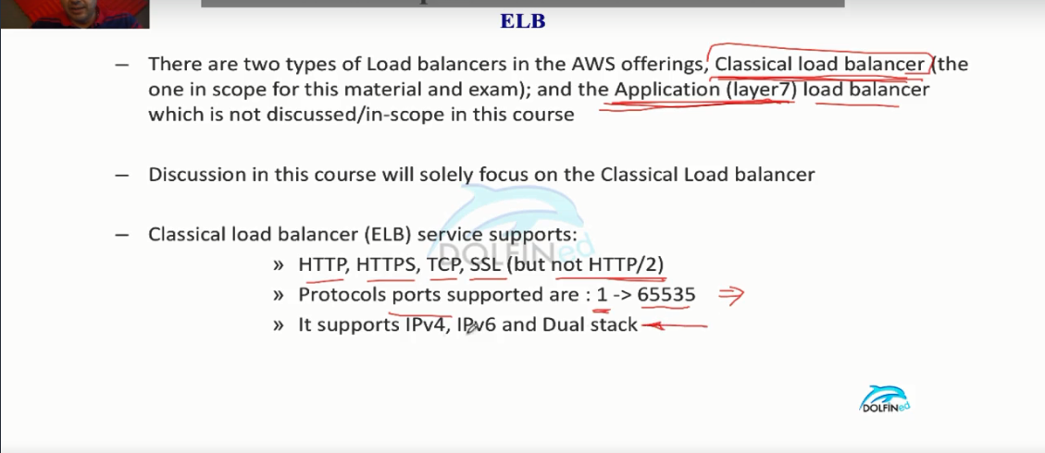

Lecture 124 - How ELB works - Continued

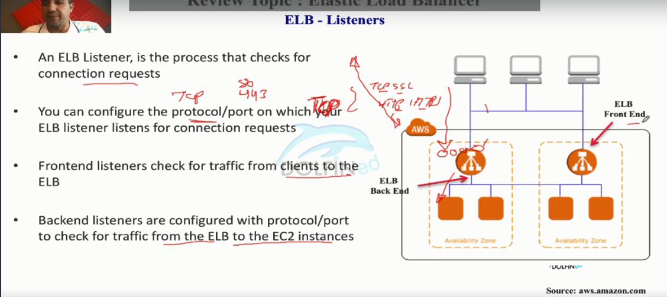

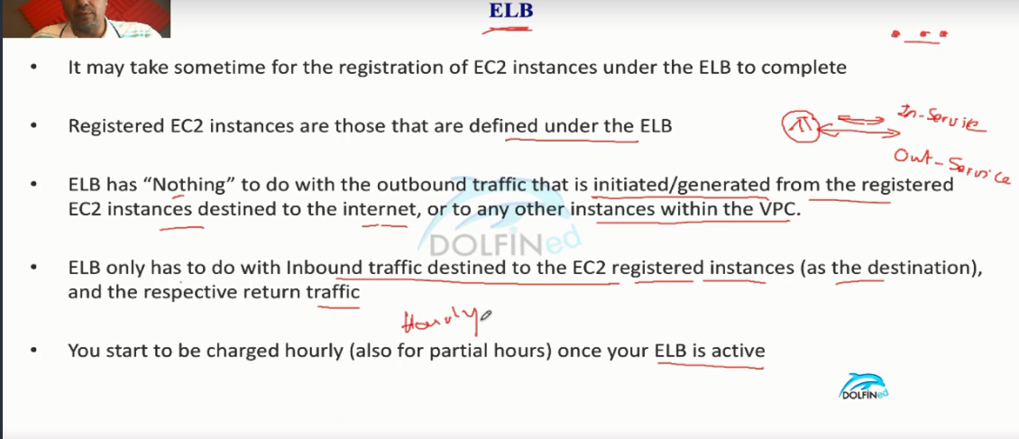

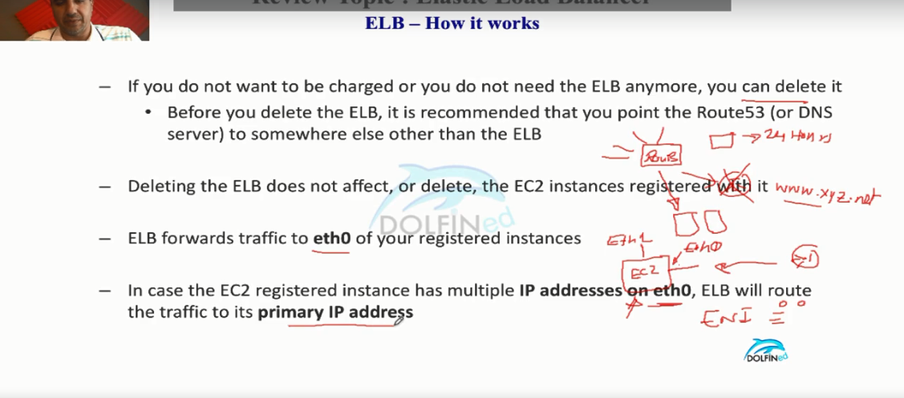

Lecture 125 - How ELB works - Again !

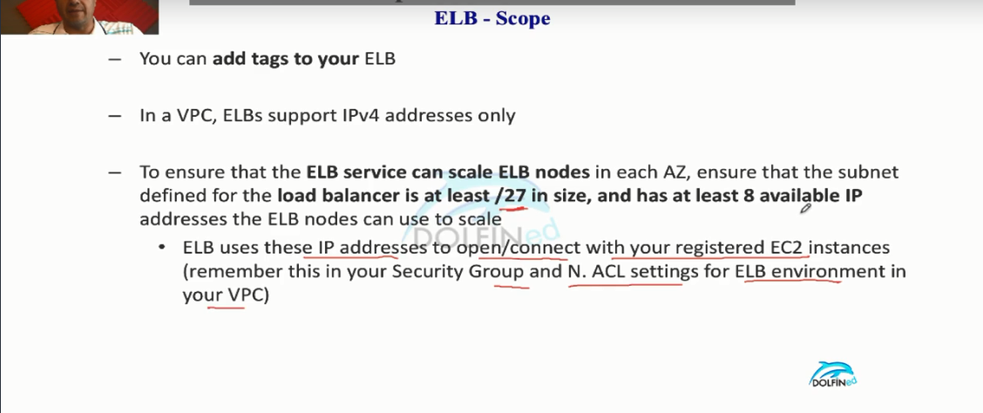

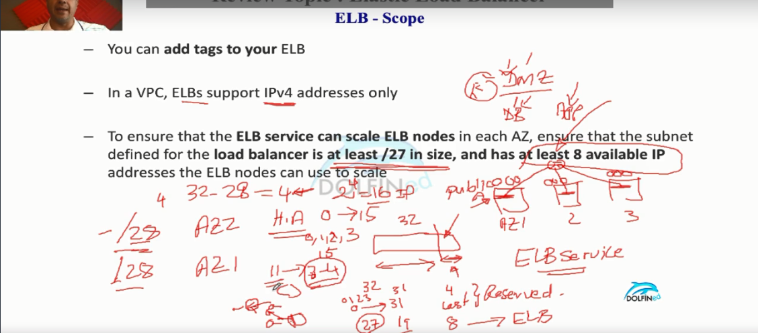

Lecture 126 - ELB health checks

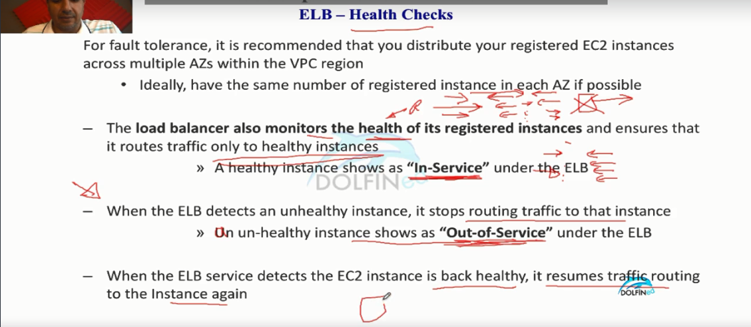

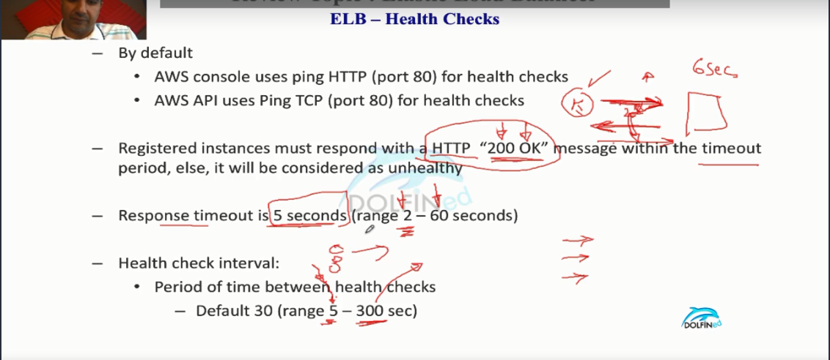

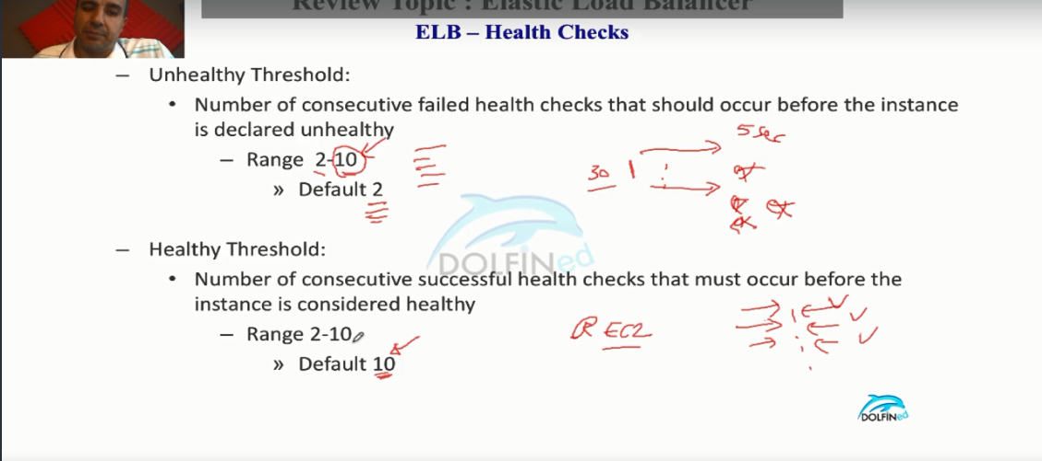

Lecture 127 - ELB Cross Zone Load Balancing

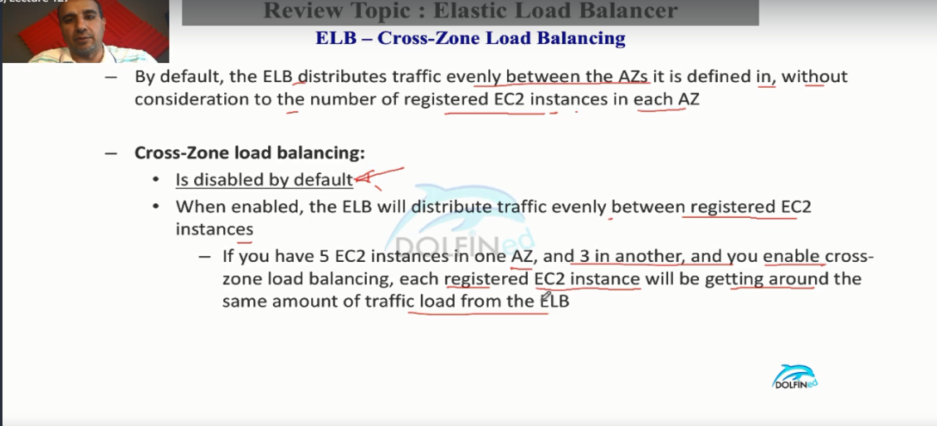

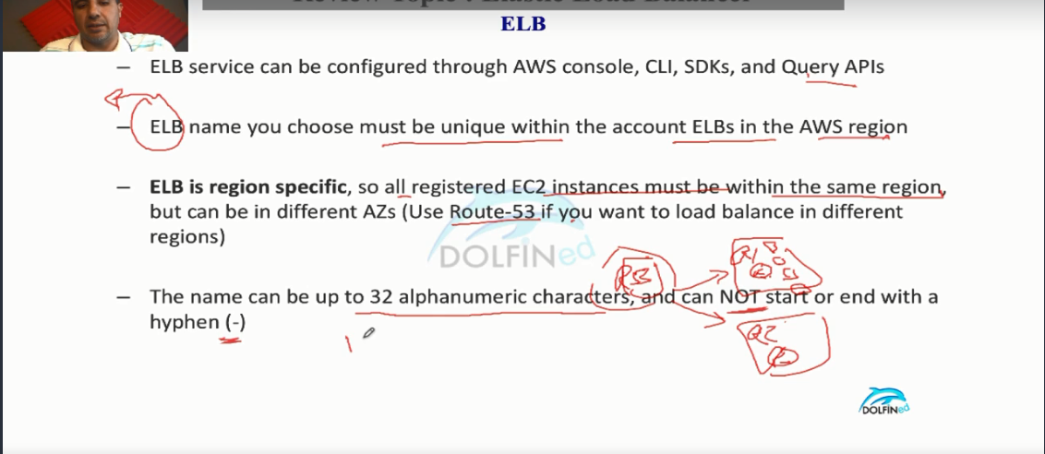

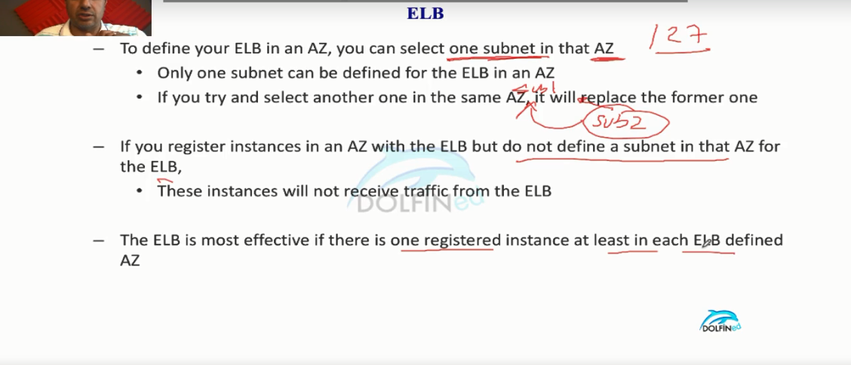

Lecture 128 - ELB Positioning - Internet-facing vs Internal ELB

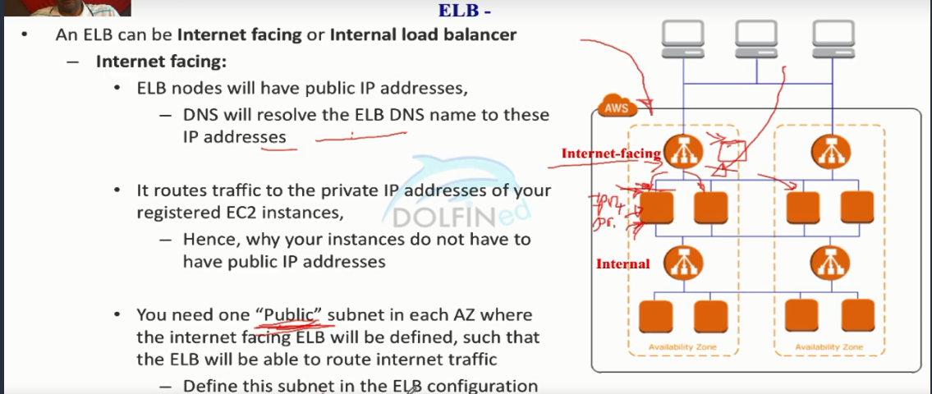

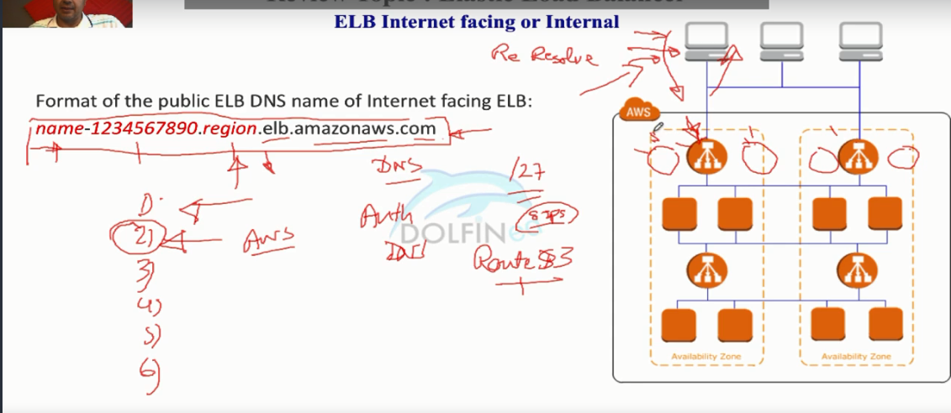

In the above pic when there is traffic increases the ELB service would launch the new nodes to facilitate it . But route53 would take care of the newly launched nodes IP addresses would be mapped to the DNS entry of the Internet facing web application (Ex: [www.example.net](http://www.example.net))

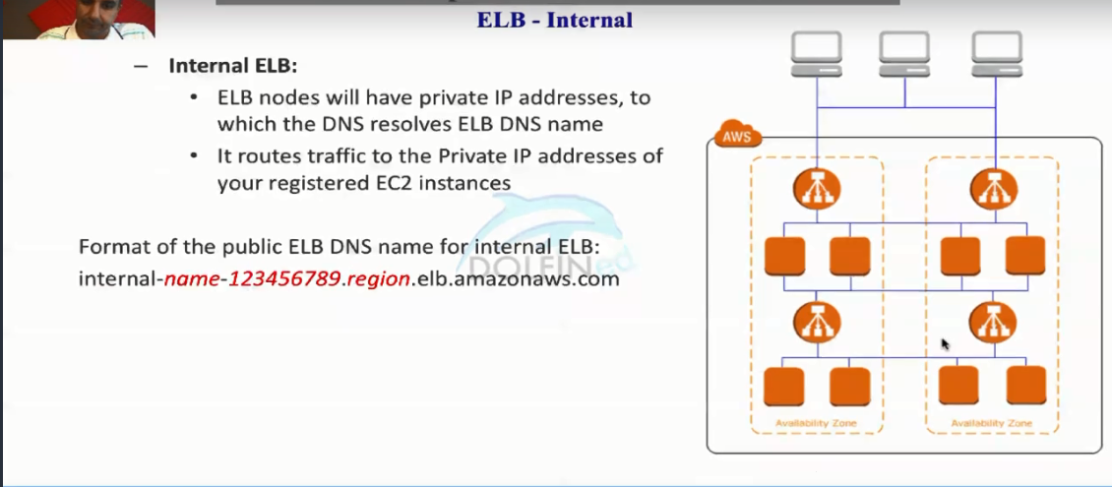

Lecture 129 -  Refresher for TCP IP Packet flow

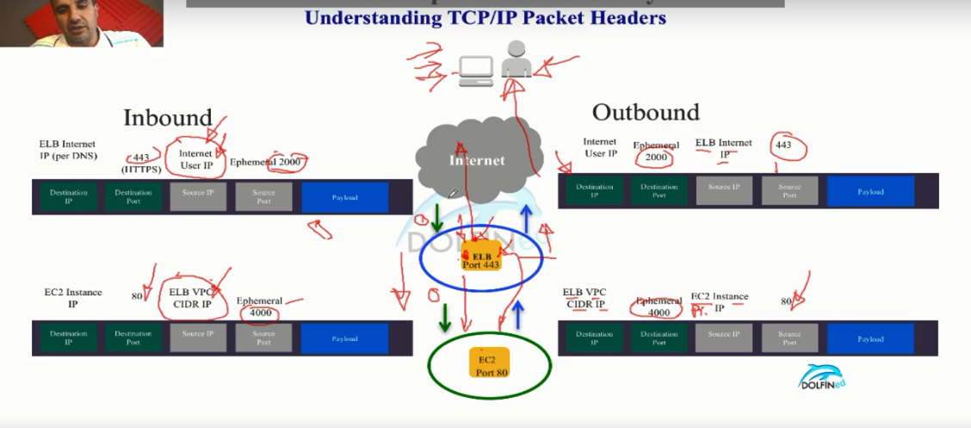

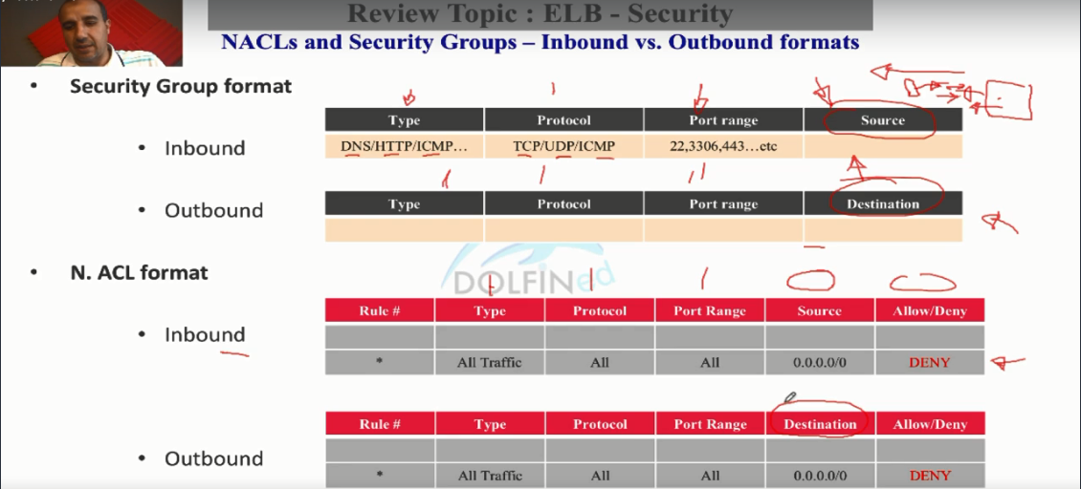

Lecture 130 - ELB - Security Group

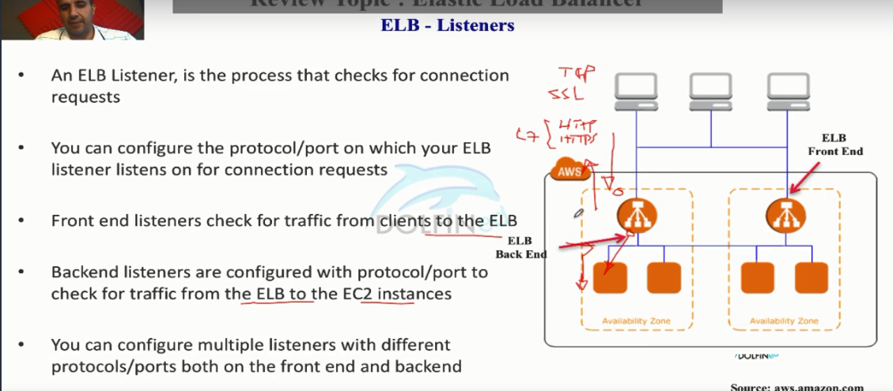

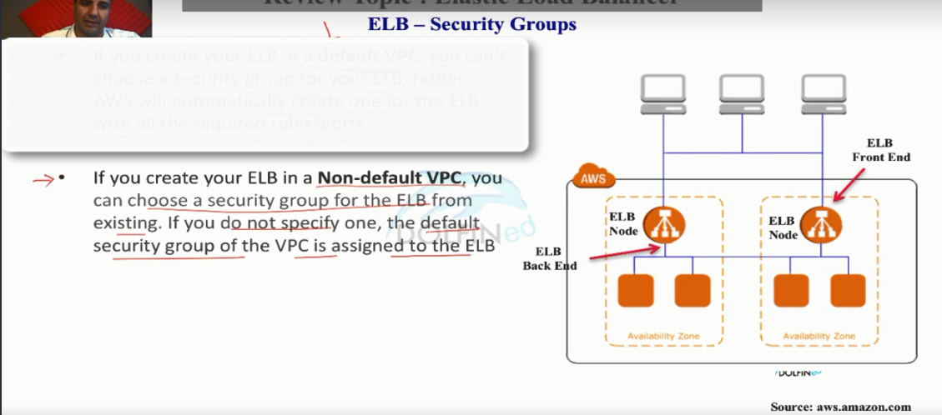

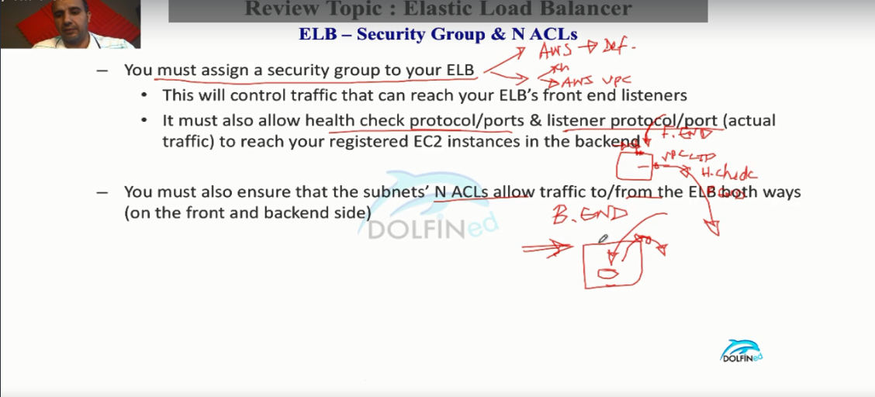

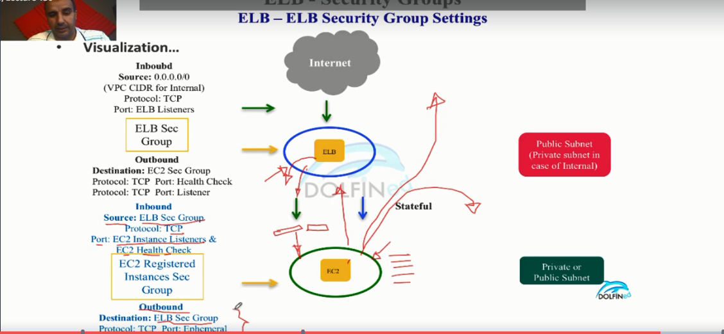

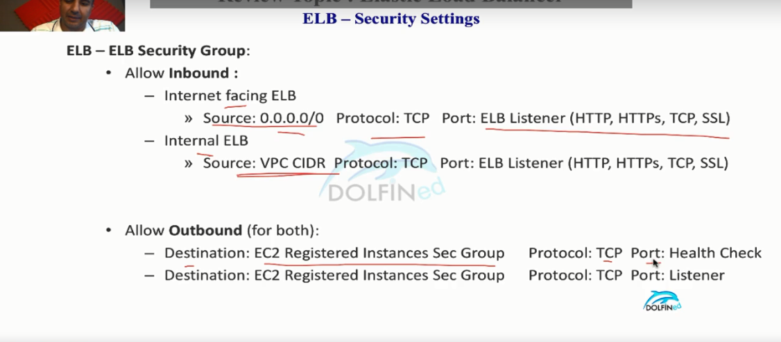

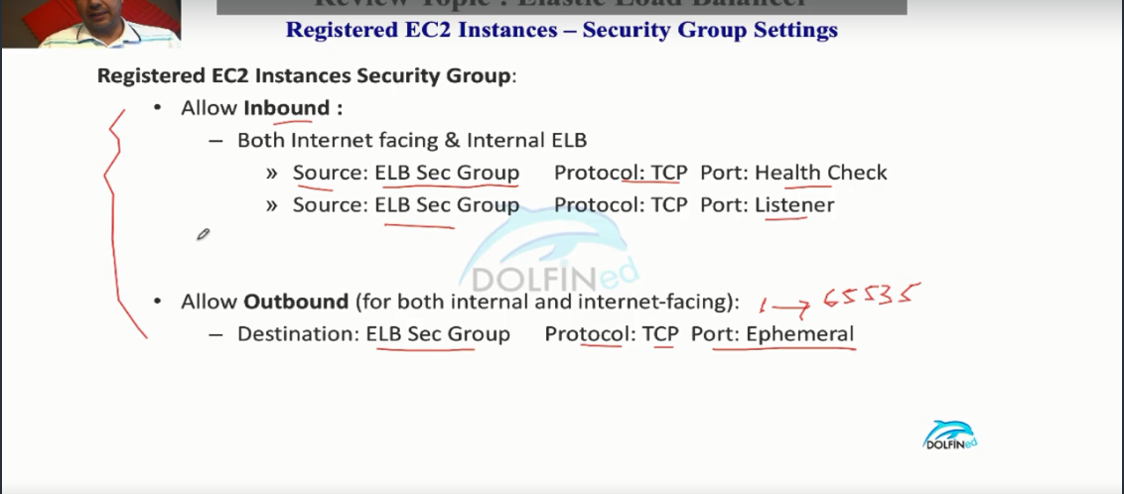

Lecture 131 - ELB - Network ACLs

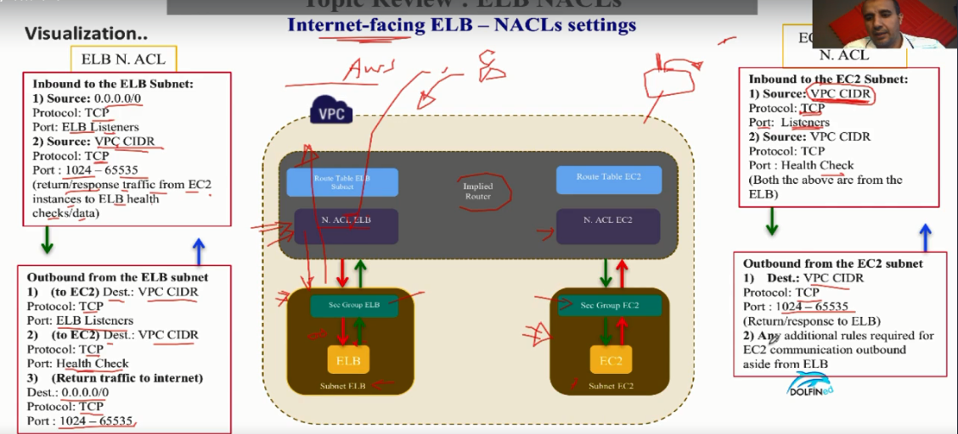

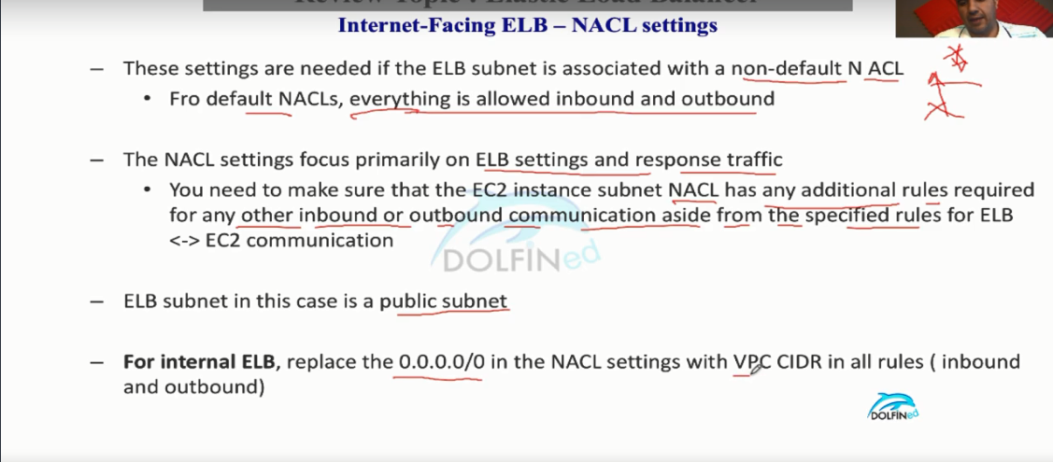



Lecture 132 - Layer 4 TCP/SSL Listeners

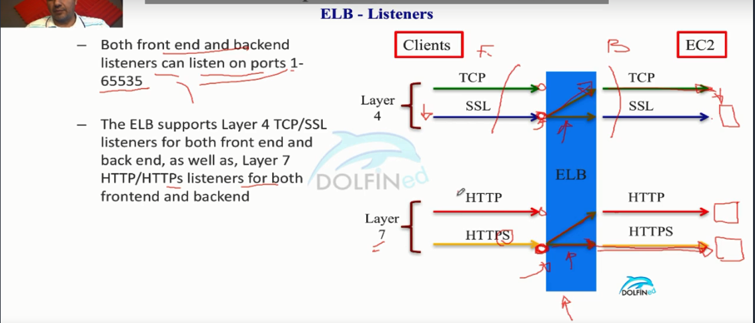

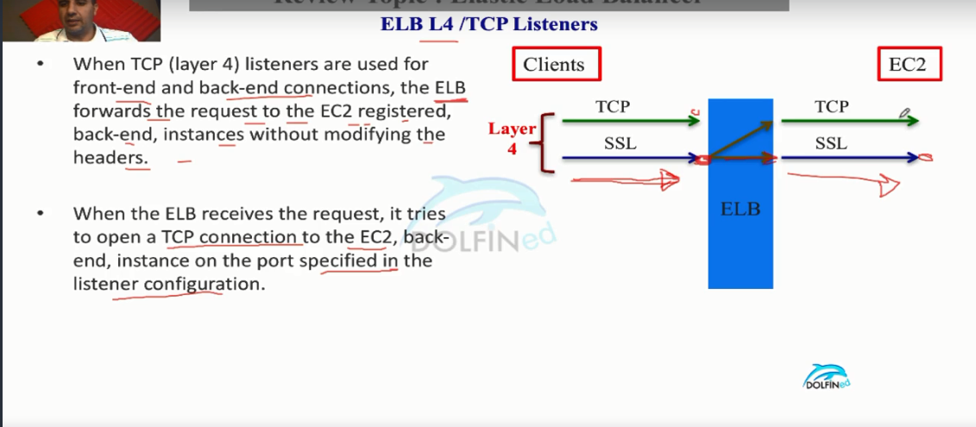

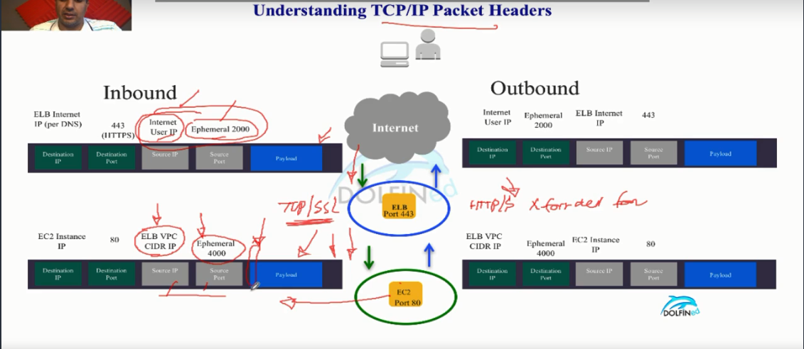

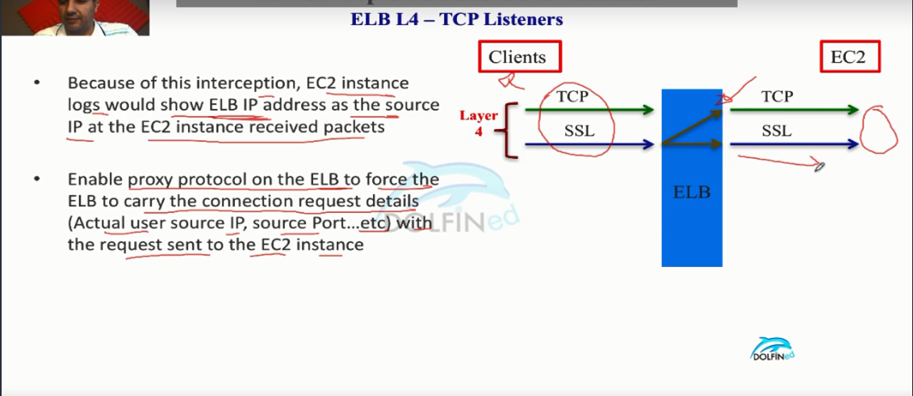

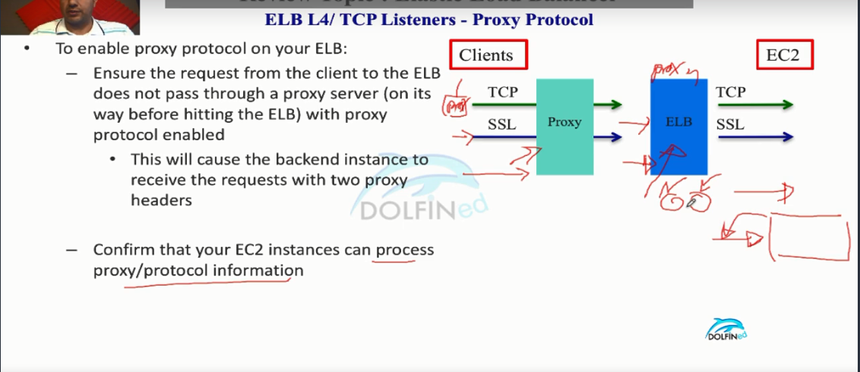

Lecture 133 - Layer 7 HTTP/HTTPS Listeners

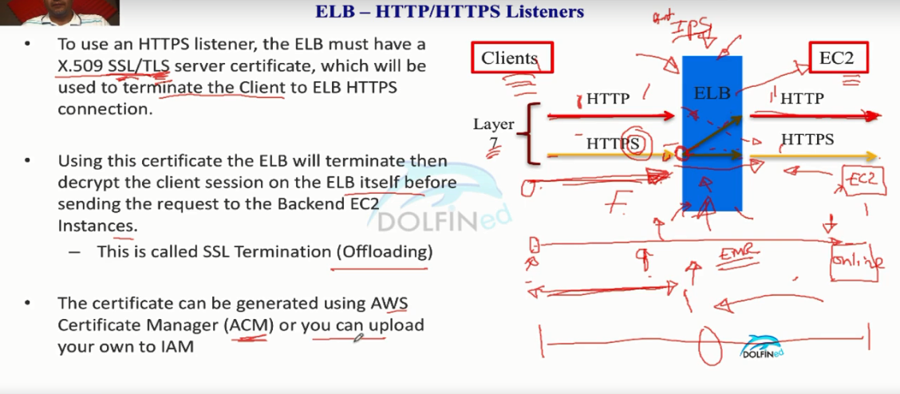

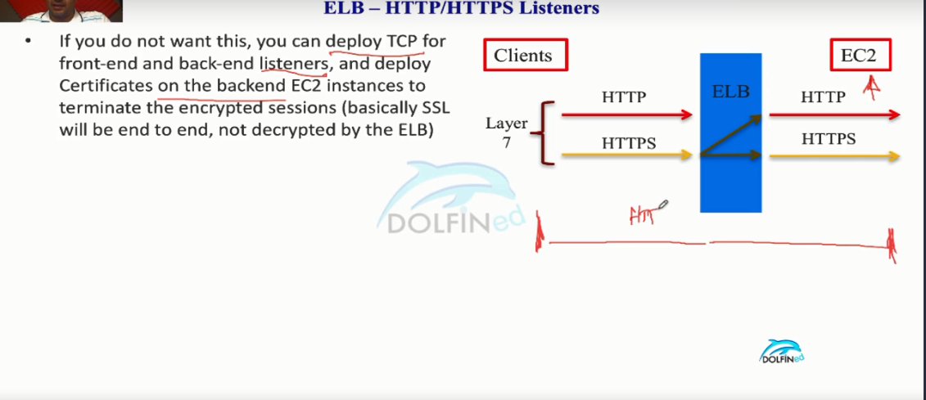

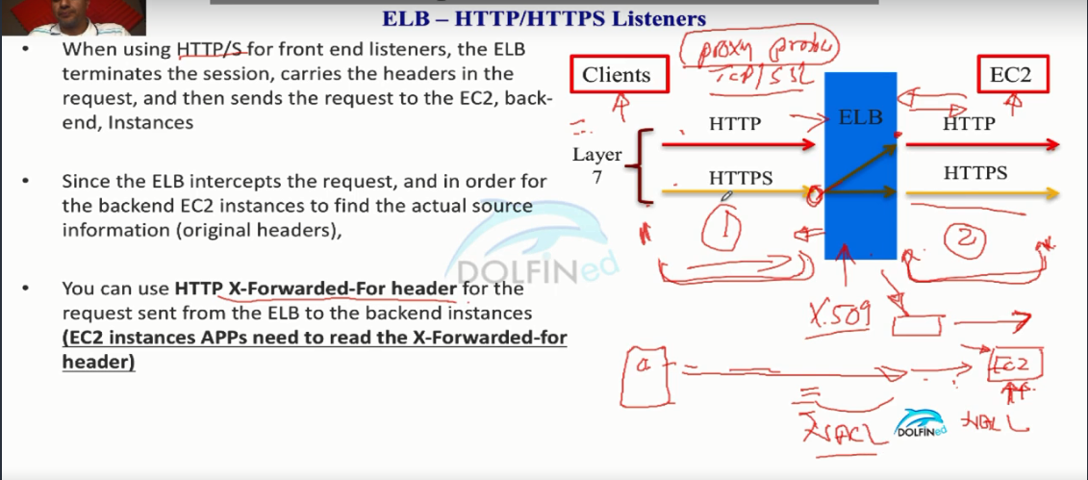

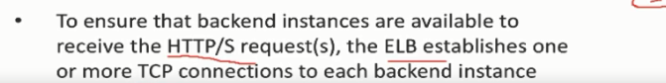

The term "TCP/IP" stands for Transmission Control Protocol / Internet Protocol and refers to a number of protocols. The "IP" part of the term, which stands for [Internet Protocol](https://searchunifiedcommunications.techtarget.com/definition/Internet-Protocol), is used by [TCP](https://searchnetworking.techtarget.com/definition/TCP)and [UDP](https://searchnetworking.techtarget.com/definition/UDP-User-Datagram-Protocol), to transport them from one network to another. Think of IP as a sort of high-way that allows other protocols to get on and find their way to other computers. TCP and UDP are the "trucks" on the highway, and the "load" they are carrying are protocols such as HTTP, [File Transfer Protocol (FTP)](https://searchenterprisewan.techtarget.com/definition/File-Transfer-Protocol) and more

Remember, IP is required to connect all networks; TCP is a mechanism that allows us to transfer data safely; and HTTP, which utilizes TCP to transfer its data, is a specific protocol used by Web servers and clients.

https://users.cs.duke.edu/~chase/cps196/slides/sockets.pdf

<http://www.firewall.cx/protocols.php>

<http://www.steves-internet-guide.com/tcpip-ports-sockets/>

Lecture 137 - ELB & Sticky Sessions (Session Affinity)

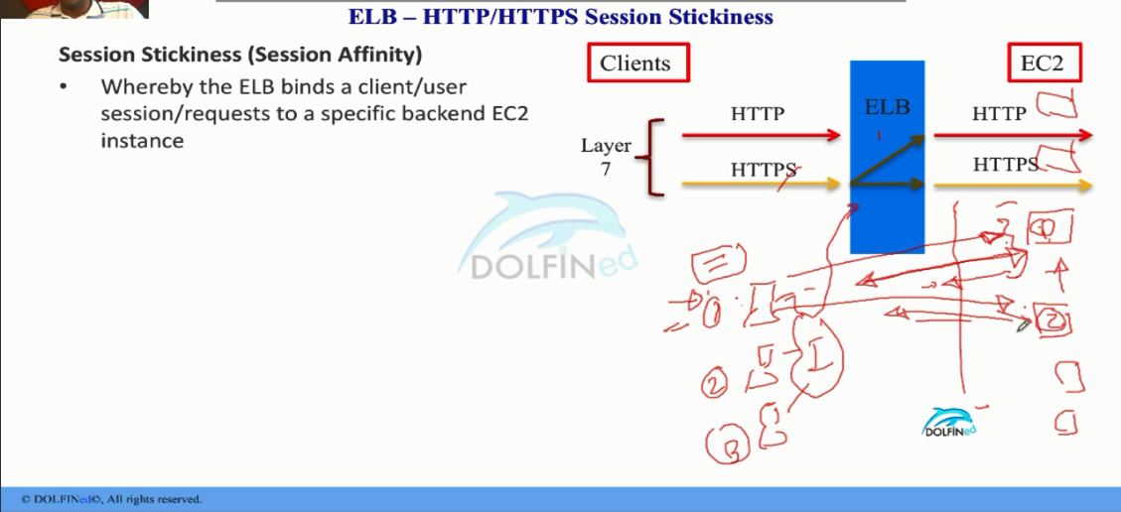

Scenario : (prologue )

From the drawing in the above pic if there are multiple users are connecting to the applications(content) on the ec2 instances behind an elb . If a user request for a web page to login and 1st ec2 provides the response with login page and user log in by providing the credentials but bcoz of the load reasons the request was sent to the 2nd ec2 instance . So , the 2nd ec2 instance do not know about the session with the 1st user going on then it cannot process it . So session affinity requires to handle this issue.

One of the solution to the above issue is below pic

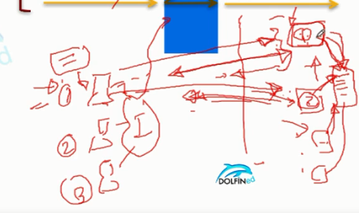

For each connection there would be a session id created by the application and cookie generated and stored on the client browser. Client uses the cookie to remain in the session based on TTL(time to live) . So the application hosted on the ec2 instances maintains a database ( Dynamodb) to store the session information against the session id generated . So whenever a new request comes from the same client if the request was forwarded to the new ec2 instance to load balance then the application would get the info from session in database and serves the request. This is completely transparent to the client browser. But it has drawbacks on the application hosted ec2 it has to I/O operation on the database that would create the hindrance in the application performance.

TO resolve this sticky session is the way.

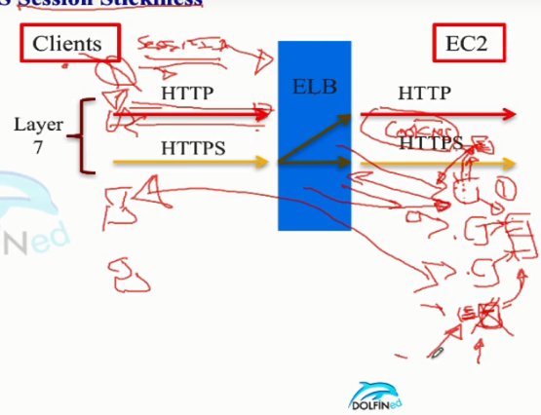

The application on the ec2 will store the session state and based on the cookie that is sent by the client will access the info of the session state and serve the request to the client and update the cookie and sent back to the client. But it has a drawback as well that what if the ec2 that is being served had crashed ( For Ex: the host which ec2 is impaired then aws will terminated in order to start on the new host) Then session info on the ec2 is gone .then the next request is forwarded to the other instance which has no clue about the state of the session as it is being cached on the local rather than a DB to avoid performance issues.

If you need you can combine both the local store of the session data and on the external DB to facilitate.

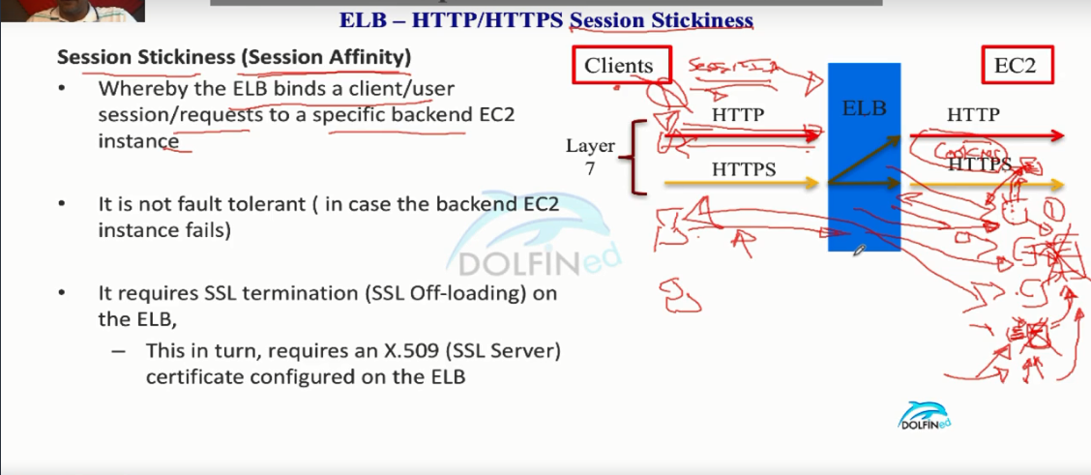

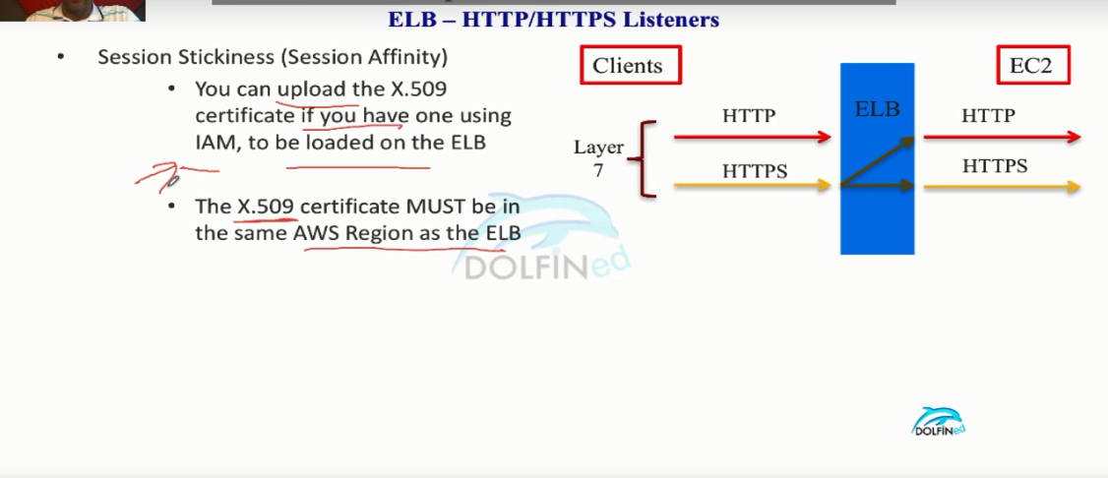

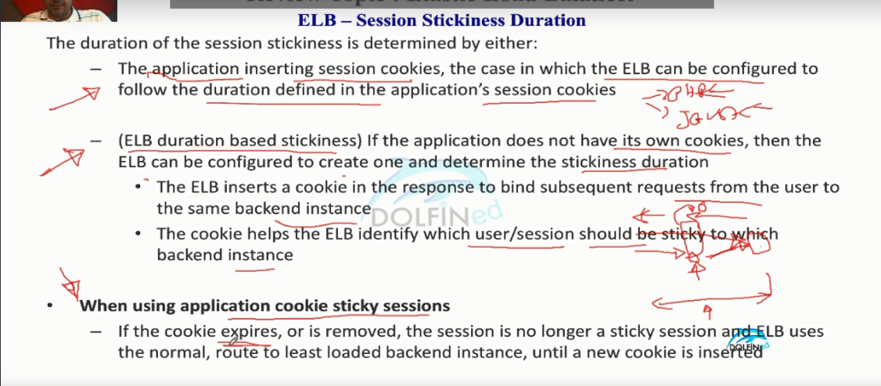

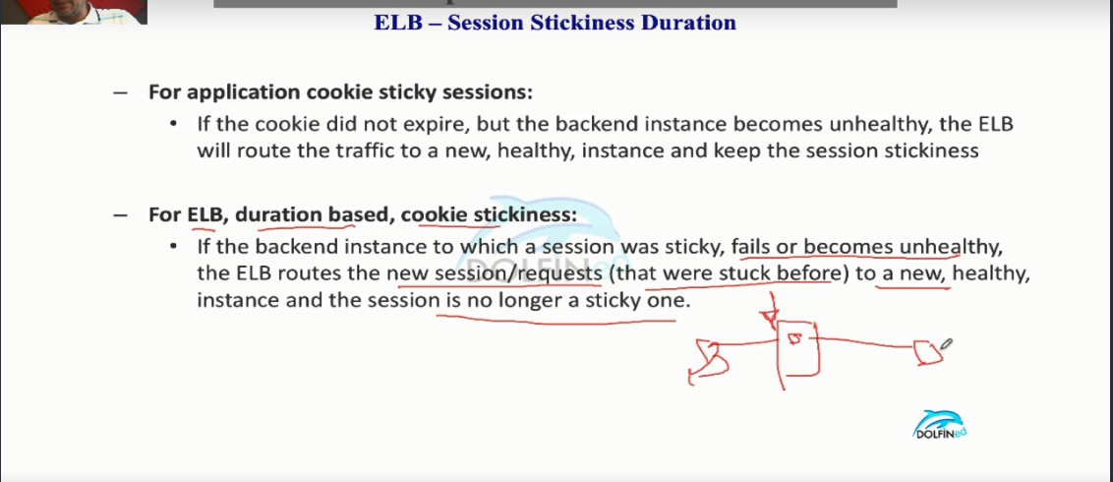

Lecture 138 - ELB Security policy for SSL/HTTPS sessions

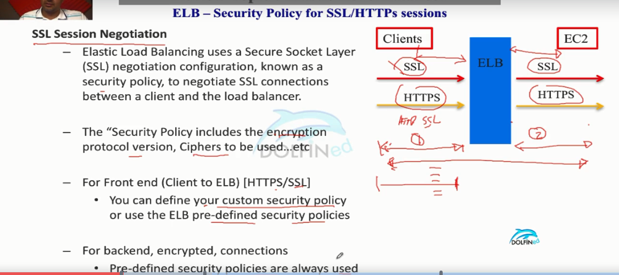

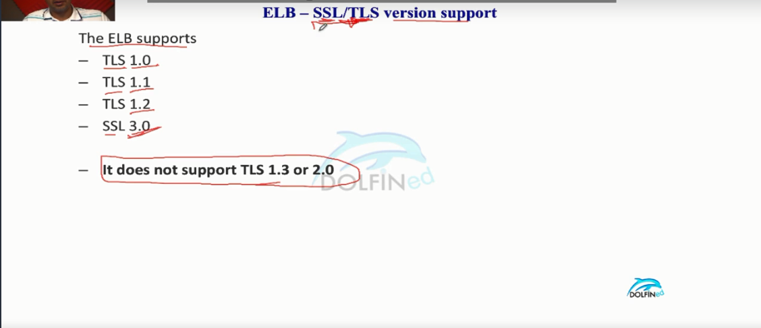

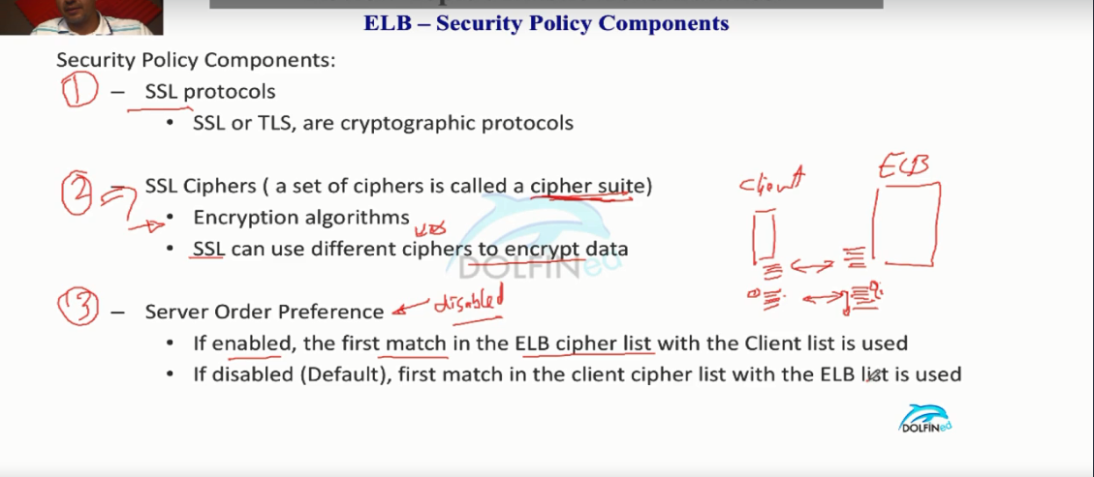

In the above pic it depicts about the ssl/tls handshake b/w client & elb. What happen is client browser will have set of protocols installed that can used in connection request ( Or which are supported ) and cipher suite to encrypt the date using encryption algorithms . Elb also possess different set of protocols and suites. When the client initiate the connection if the server order preference is enabled then elb would be checking the list of cipher suites on browser i.e.., pick one cipher and go through the client and if it matches use that for the encryption , If it unable to find then pick 2nd one on the elb suite and find a match on the client.

If server order preference is disabled then it would work other way around.

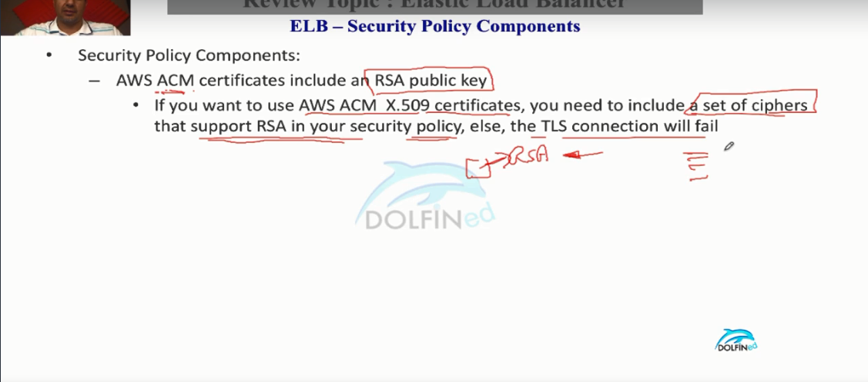



Lecture 139 - SSL/HTTPS authentication - Client and Server Certificates

Lecture 140 - ELB Connection Draining

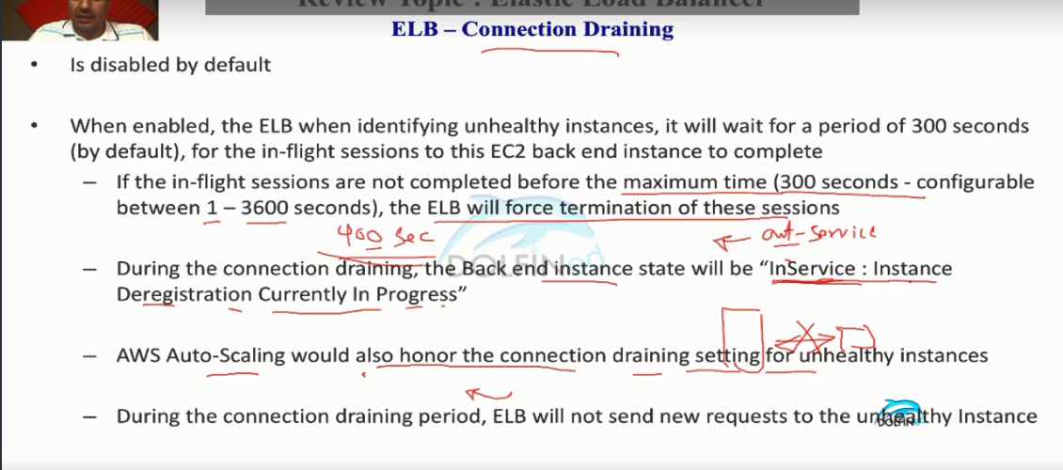

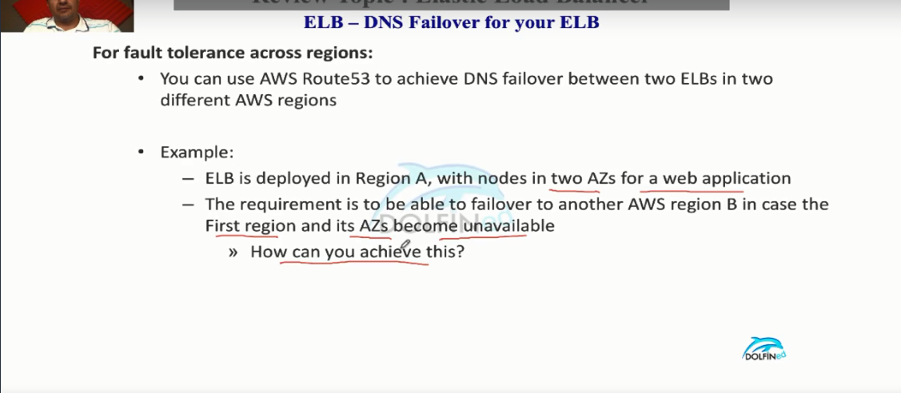

Lecture 141 -  ELB Monitoring

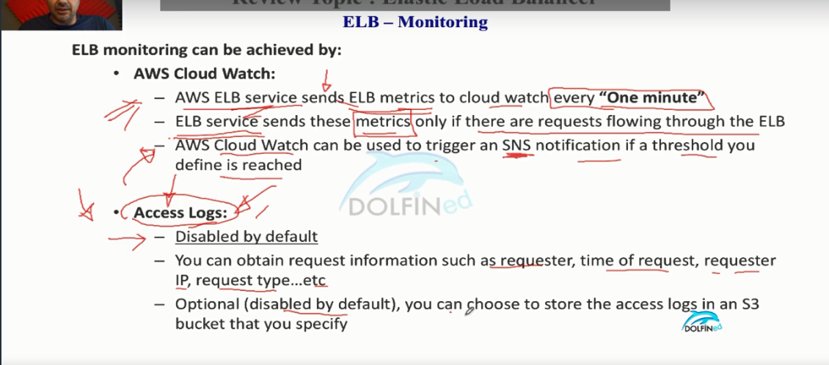

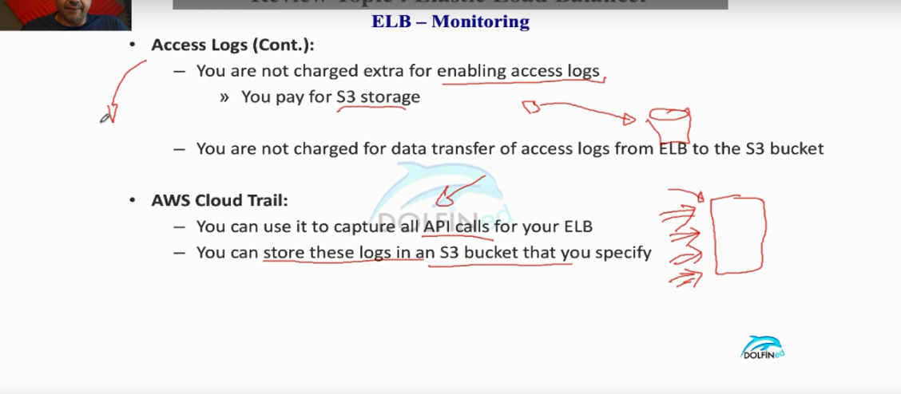

Lecture 142 - ELB Pre-Warming & Scaling

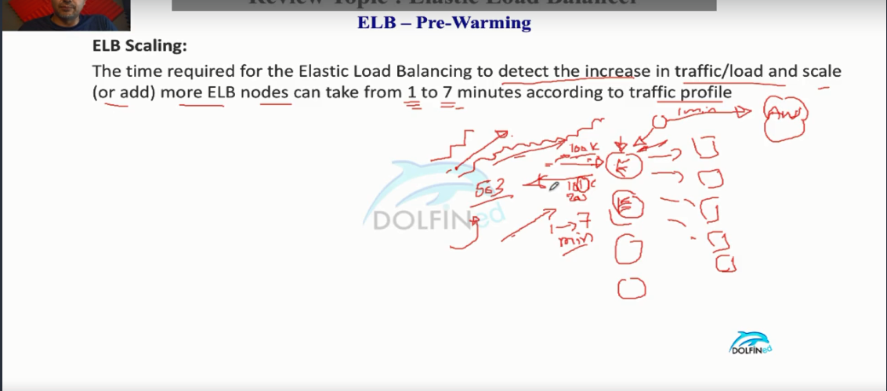

From the above pic if the traffic from the clients increase in the liner or step fashion ( In frequent time intervals ) . For example if the ELB can handle 100 K requests per sec but there is 101 K requests per sec then elb service will launch new elb node to cater it ( In background as elb service will send the cloudwatch metrics per min the aws detects there is a need to launch new nodes then it will launch ) . But if the traffic is exponential( sudden spike) it cannot handle because it needs at least 1-7 Min to launch new node.

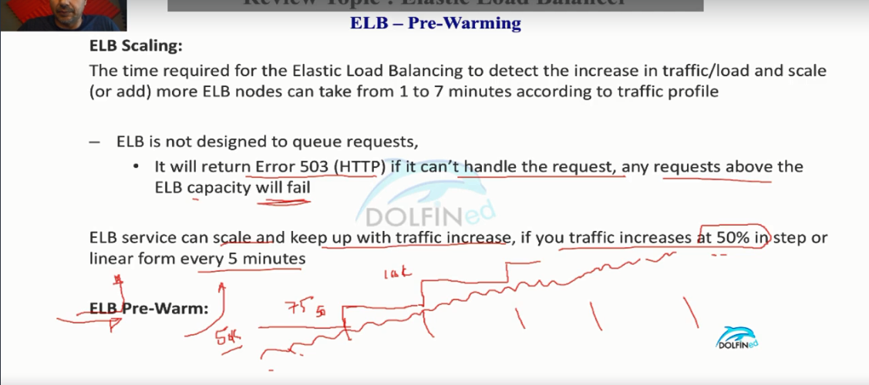

If you expect a sudden spike in traffic in near future then you need to contact aws to facilitate that in advance.

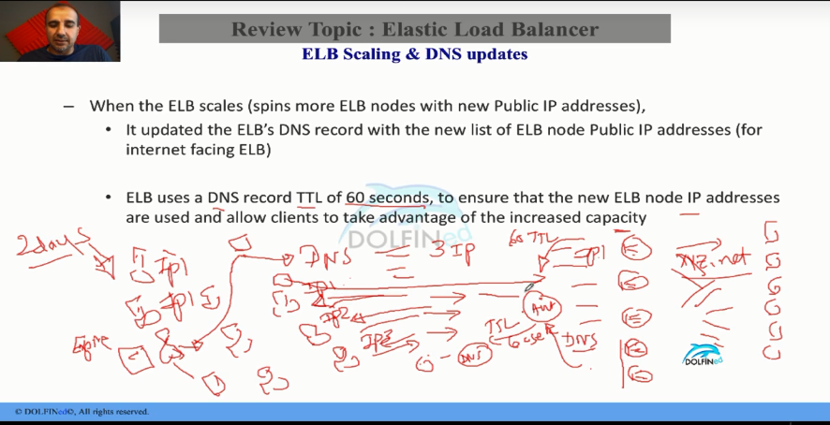

In the above pic if the aws launches new elb nodes route53 will update it’s dns records to map the new ip addresses to the domain name. So that every client can request will be distributed evenly on the elb nodes. And also if the client ttl(time to live) is huge ( 2 days) then for every request it would re resolve the ip address for every 2 days that would cause the client would connect to the same elb to resolve it we set minimum ttl .

Lecture -143 Testing you ELB scaling (or applications servers by ELB)

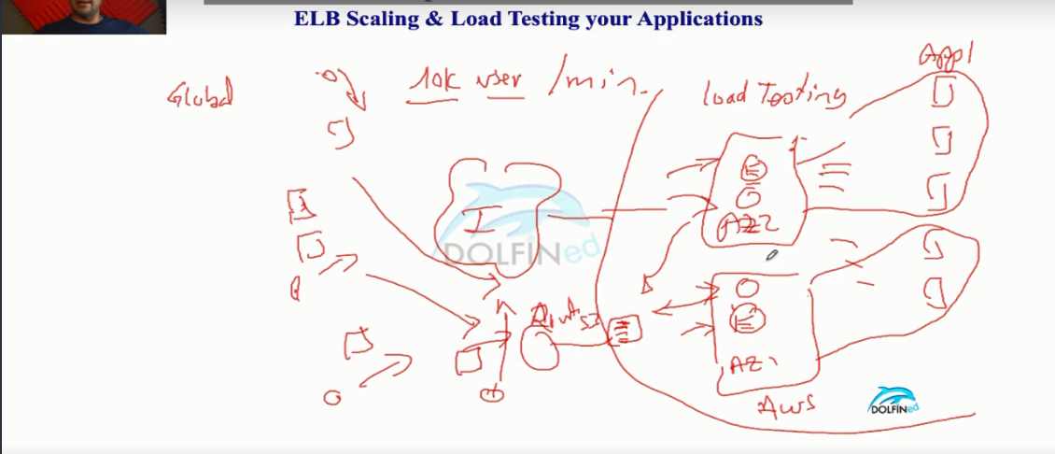

For example if you are launching a new app in aws that expects 10k user request/min . Then you want to load test the app . You will choose a Global stress testing provider that have different probes across the globe which have dns resolver on it’s own. When the traffic increases then the elb service launch new nodes which increases the ip address that will be update to Route53 DNS records for the domain. So every request Route53 would serve the different ip round robin robin fashion that would in turn cause the elb to split the load on the ec2 insatnces.

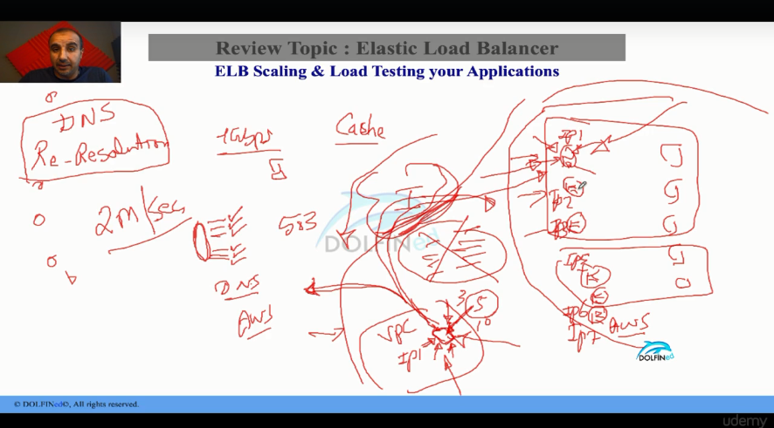

If we are load testing from with in the vpc ec2 instance for cost reasons to avoid 3rd party provider then the Ec2 instance that is being used for testing has to flush the cache for every request ( DNS has to set very minimal TTL). What is the reason ?

From above pic if you consider that we have 2 AZ(Availability Zone ) which has distributed the instances and when you test it the ec2 will not flush the DNS entry which causes the Ec2 to go the same elb node for every request which causes the elb to launch the new instances which will DNS Records but not being used which incur charges.

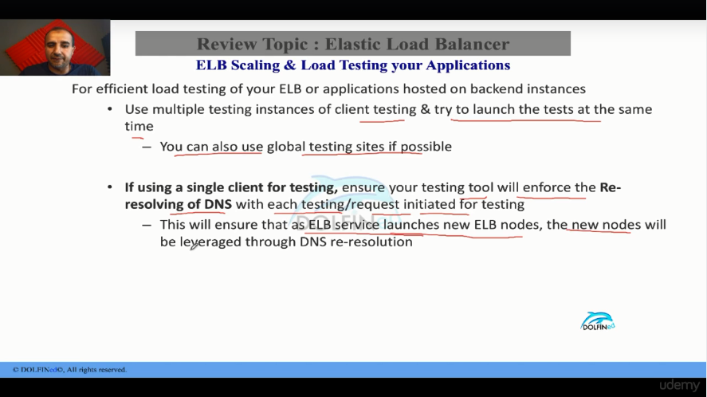

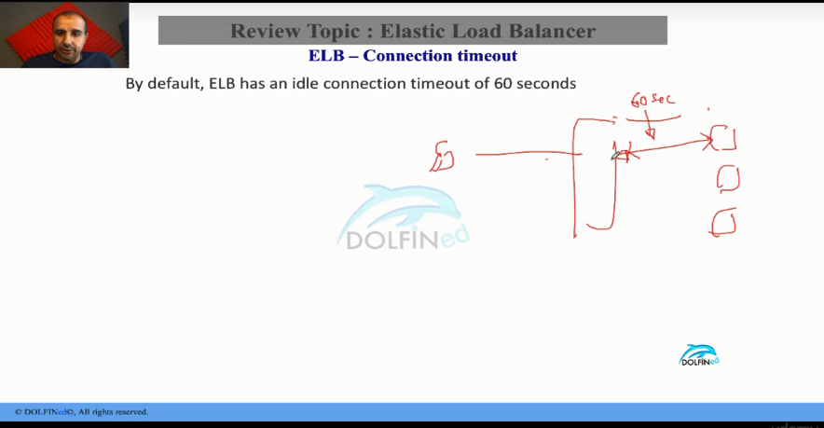

If no traffic is flowing b/w the connection established with elb & ec2 then it will terminate the connection.

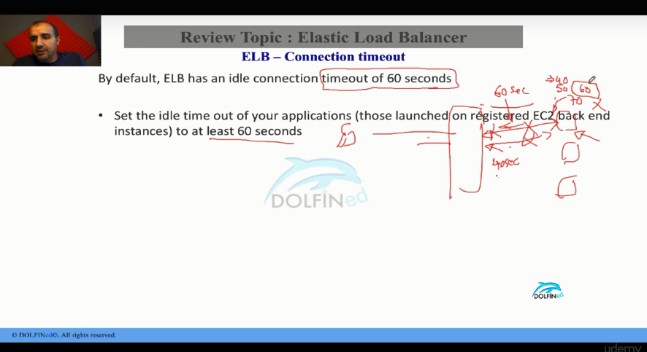

If the application on ec2 has set the time limit below 60 seconds then it will terminate the request after reaching the time which below 60 then elb service consider it as a unhealthy instance stop sending request to it as elb has 60 sec timeout.